TWNG Platform

MVP Page Architecture & Content Specification
Updated: May 28, 2025

Preface
This document presents the proposed structure for the first MVP version of the TWNG platform.
It outlines the key pages and components needed to support the platform’s basic functionality, based on what we’ve discussed so far (with some small additions).
The focus is on creating a solid user experience and a clear content framework, both for collectors and professionals. The goal is to define what needs to be built in the first stage, so we can move forward with aligned expectations and priorities.

HOMEPAGE STRUCTURE
The homepage should introduce TWNG, encourage exploration, and highlight community activity.

Current Elements
- Hero section: slogan, CTA to "Document Your Guitar", visible yet non-intrusive
- Featured Guitars / Collections
- About TWNG (short intro)

To Be Added
- Community Snapshot: Recent uploads, active members, verified guitars* (future badge or ribbon)
- "Surprise me": Show me a random collection (not really random, one of collections we marked as "show-worthy"
- Spotlight on Luthiers: Highlight verified professionals. To be triggered when we have XX number of verified professionals.
- Content Teasers: Excerpts from articles, interviews, guides
- Social Proof: Quotes/testimonials from collectors or luthiers
- Navigation Improvements: Top nav bar to various sections like "Explore", "Search", "Upload", "Verified Guitars" (future), "For Sale*" (future), "Luthiers", "Articles", "Profile"

COLLECTION PAGE (User-Owned Collection)

Sections:
- Collection Title & Description (user provided)
- Owner Information (username, profile pic, linked to profile)
- Grid of Guitars with short info cards, linked to instrument pages
- Filter / Sort tools
- Export / Share button in platform and social.

INSTRUMENT PAGE (Single Guitar View)

Core Elements:
- User-given instrument name
- "Official" model name, brand, year, serial number
- High-res images / video gallery
- Full user provided description / history ("story")
- Timeline (repairs, owners, mods)
- Tags (customizable)
- Luthier Verification (if exists)
- Call to action (“Add to Collection”, "Verify This Guitar", "Add to Guitars I'm watching")
- Related guitars / similar models
- For Sale: Link to Reverb or similar

USER PROFILE PAGE

Structure:
- Profile name (user known-as name)
- Location (country / state / area / city…) optional
- Avatar/Photo / Bio / Social links
- Number of Guitars / Collections / Verified Items on TWNG
- Public Collections Grid

Future (non-MVP)
- Badges / Community Status
- Follow Button (if future social features added)
- Reviews from Luthiers

UPLOAD GUITAR PAGE

Form Fields:
- User-given name, Brand, Year, Model, Serial
- Upload images / videos links
- Text editor for story/history
- Timeline creator and editor
- Add to Collection (existing / new)

Future (non-MVP)
- Request Verification (checkbox)

VERIFICATION PAGE

Purpose
Manage and track all verification requests.

Sections
- Guitar Thumbnail + Short Info
- Luthier Search / Luthier Assigned / Status (Pending, In Review, Verified, Denied)
- Timestamp
- View Certificate (PDF/HTML link)
- Comment Thread (optional)

LUTHIER DIRECTORY & PROFILES

Directory Page
- Filter by Country / City / Specialty / Rating
- Profile Previews with Verification Stats

Luthier Profile
- Bio + Credentials
- Services Offered
- Verified Guitars List
- Reviews from Users
- Contact / Booking CTA

ARTICLES & GUIDES SECTION

Landing Page
- Search + Filter (by type: story, guide, interview)
- Cards: Title, Author, Tags, Preview Text

Article Page
- Full article format
- Author Bio
- Share Buttons
- Comments

SEARCH RESULTS PAGE

Structure
- Search bar at top (part of nav bar)
- Filters: Year, Model, Tags, Luthier Verified
- View: Grid/List Toggle
- Results: Image, Title, Short Desc, Owner, Verification Icon* future

STATIC PAGES
- About TWNG
- Our mission & founders
- FAQ
- Terms of Use
- Privacy Policy
- Community Guidelines

OPTIONAL (POST-MVP)
- Notifications Page (alerts, likes, verification updates)
- Events Page (exhibitions, meetups, livestreams)
- Saved Items / Guitars I'll keep an eye on
- Marketplace Listings

Instrument page 1
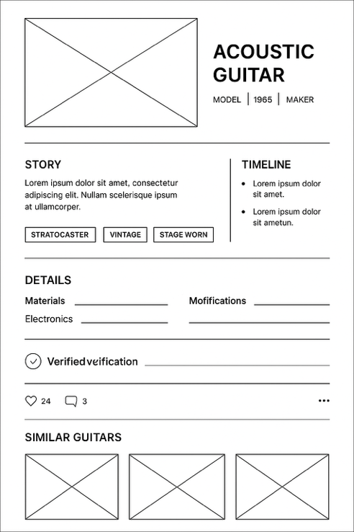

Instrument page 2
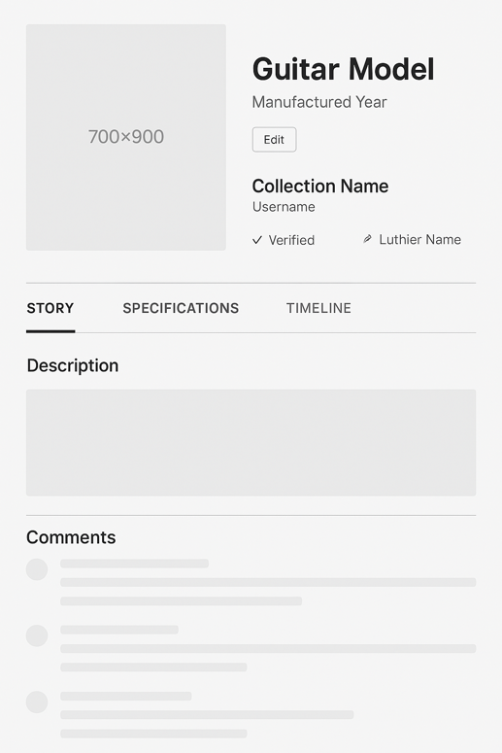
Instrument upload (Page or form?)
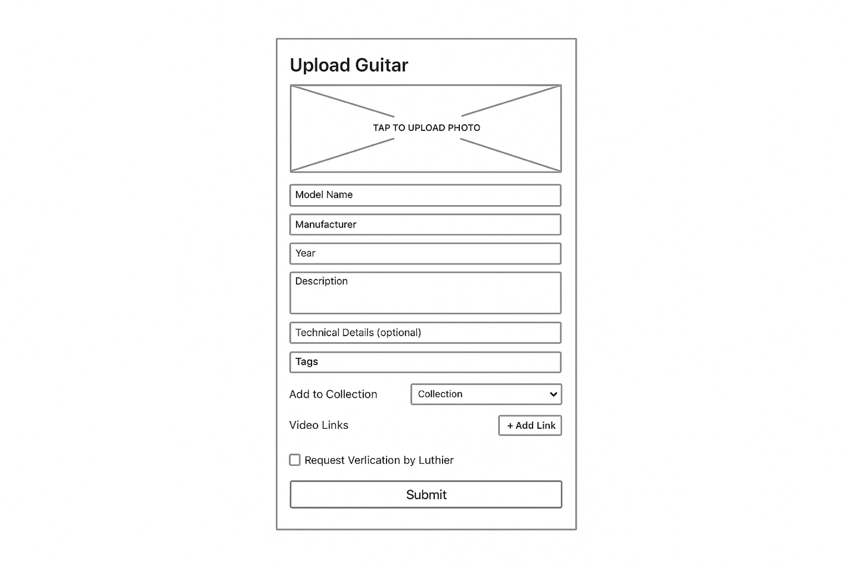

Collection

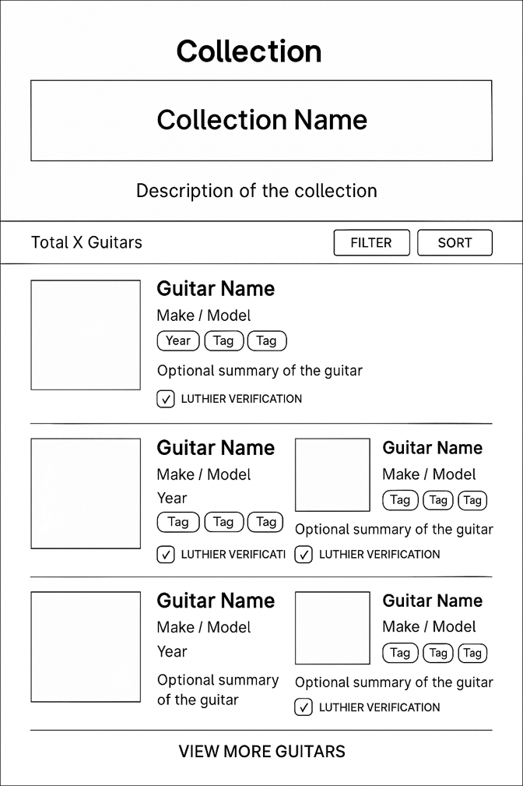

Home Page

